Students Handout
MVC(Model View Controller)Exercise1

Overview:
In this exercise, you will create a simple Job Portal with three controllers: JobSeekerController, and Public Controller. The application allows job seekers to register, log in, view and update their profiles, view a list of jobs, view full job details, apply for jobs.
Technologies:
ASP.NET Core MVC
C#
Repository Pattern
Dependency Injection

Exercise Steps:
Create Public Controller with Following Action
1.Registration
2.Login
Create JobSeeker Controller
1.Profile
2.Post Action For Profile update
3.ListAllJobs
4.ApplyJob
Repository Pattern:
Implement a generic repository pattern for handling data access.
Create repositories for User, and Job
Register services in IOC Container

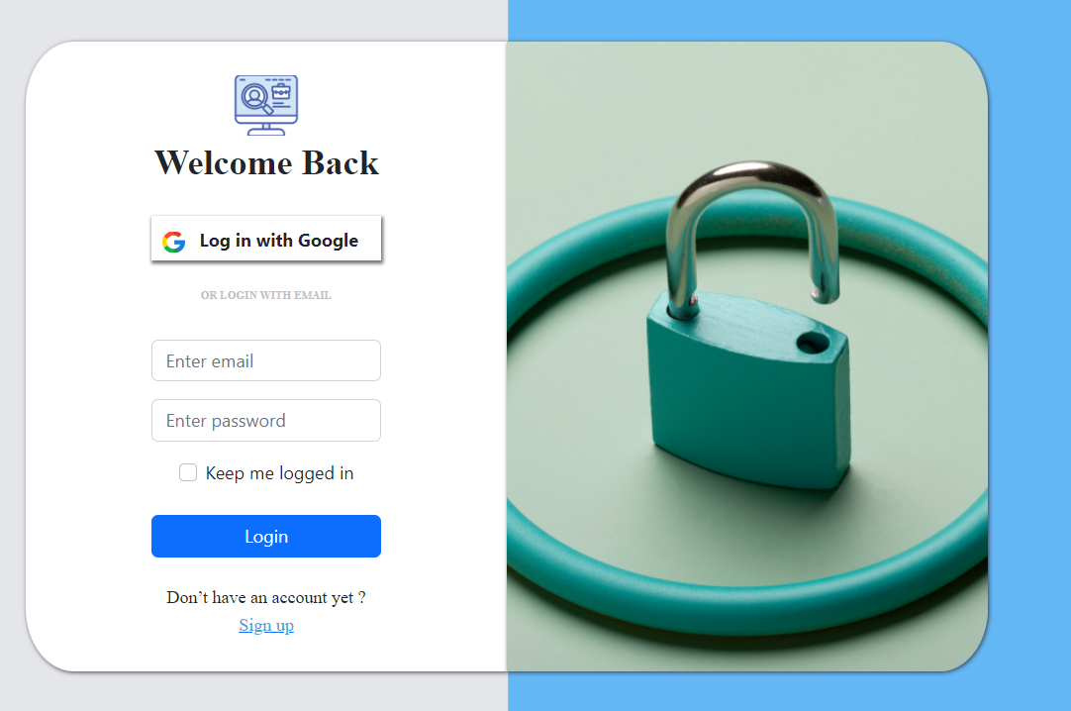
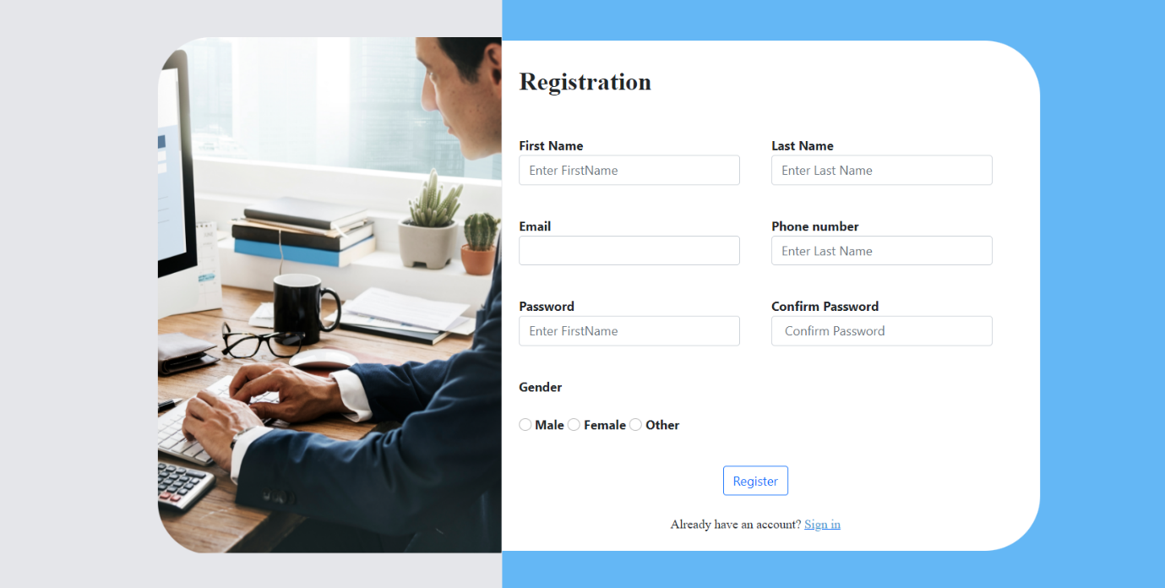
Create A JobseekerController There is actions for View and update profile of logged User.,List all jobs,apply Jobs
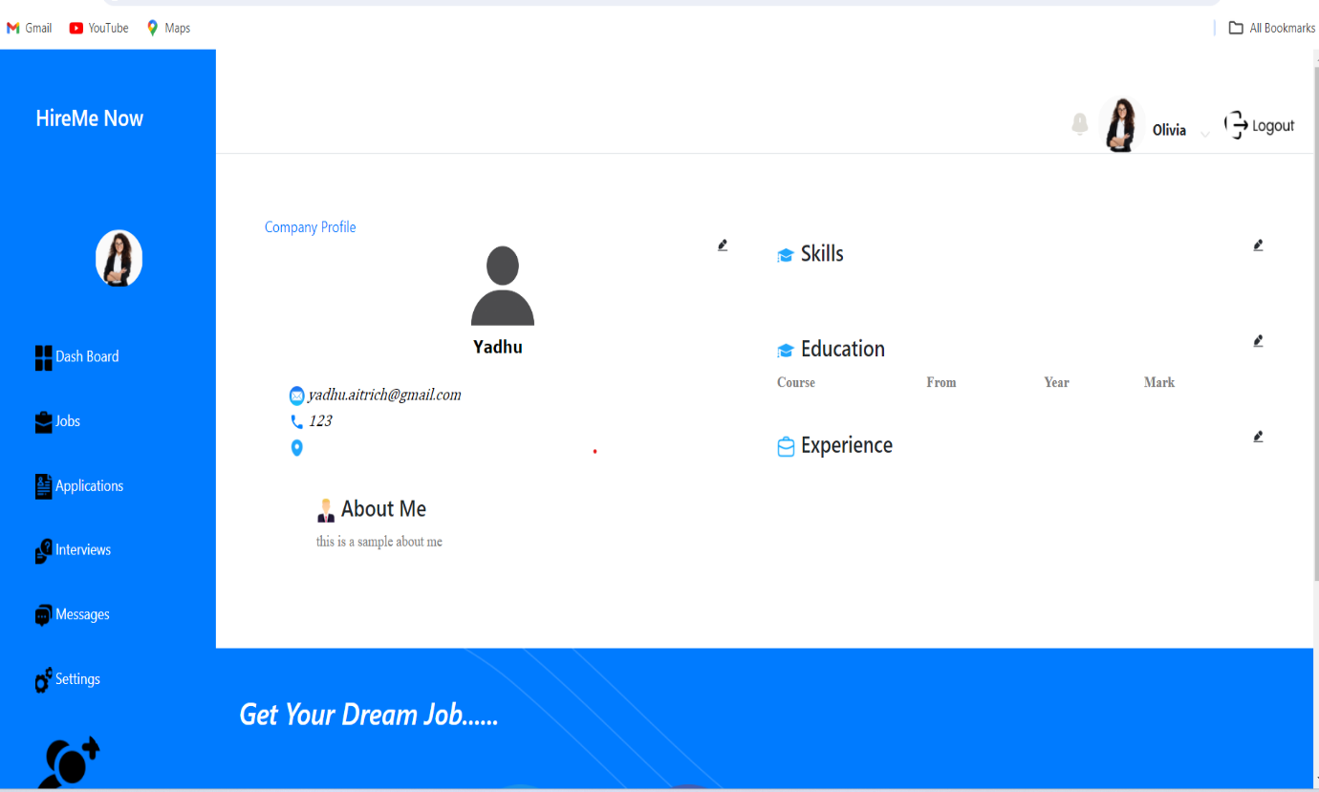
Jobs List
